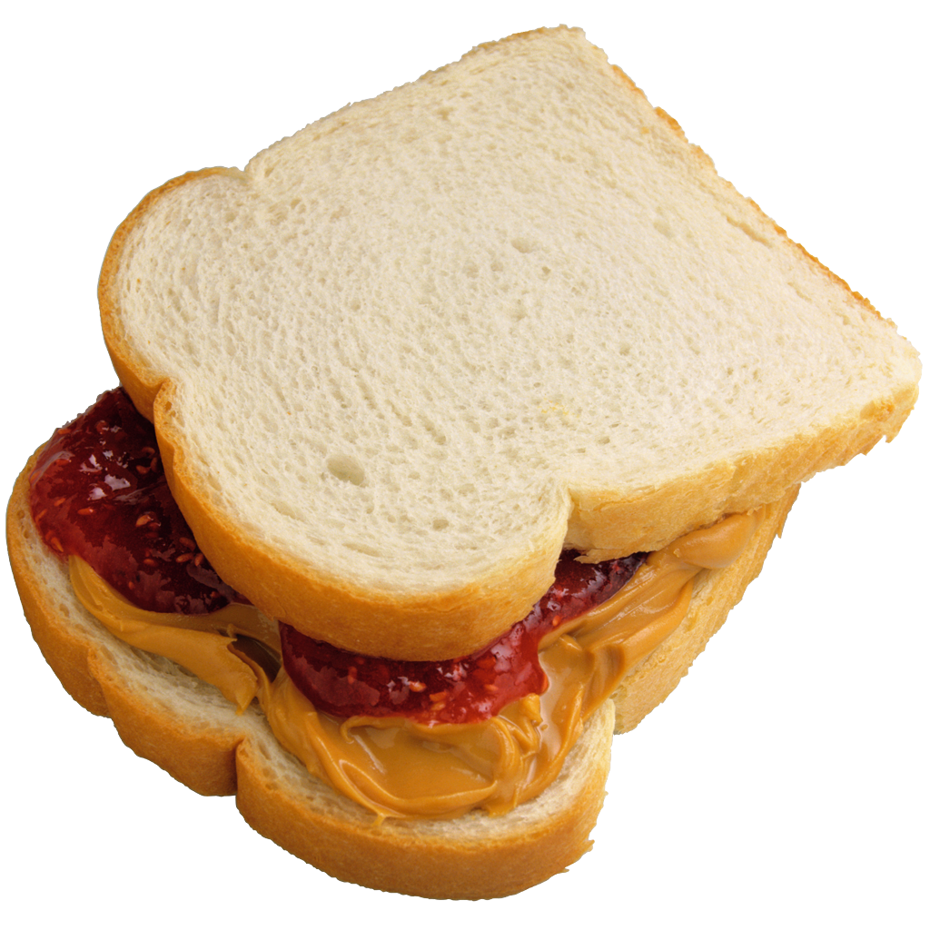 Food Labels Worksheet 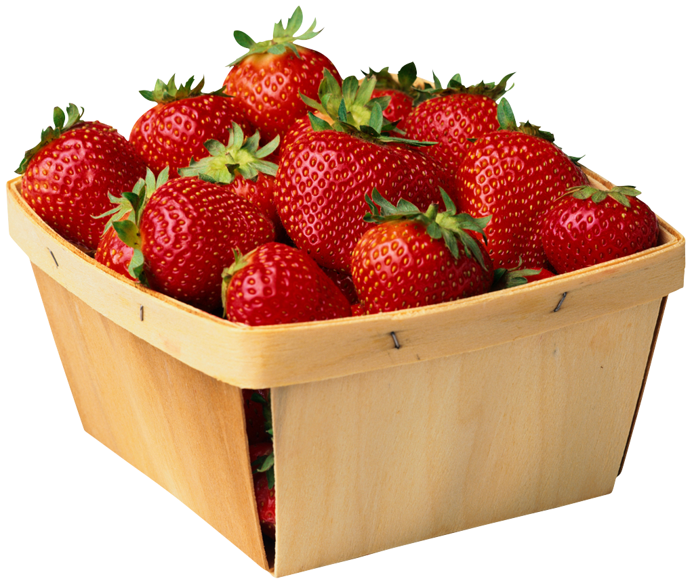

Name of food #1 _____________________
- What is the serving size?
- How many servings per container?
- How many calories from fat?
- Is there any Calcium in the food? YES or NO If yes, how much?

Name of food #2 _____________________
- How many calories per serving?
- How much total fat? Is there saturated fat? YES or No If yes, how much?
- How much dietary fiber is in the food?
- What is the % of Daily Value of cholesterol?

Comparing your two foods
- Which of the two foods has more calories per serving?
- Does either food have 30% of your Daily Value for any vitamin?
- If you eat two times the amount in one serving of food #2, how would you find out the number of calories you have consumed?
- Percent of Daily Values is based on a ________________ calorie diet.

